BOLTON ACADEMY
Date: August 28, 2024
Time: 6:00 PM
Recording: Zoom recording at
https://www.youtube.com/live/O5-fmzfXL1I?si=U2btMsLuEGrnfuRl

- Call to order: Meeting called to order by Shavaun Mincey at 6:06pm
- Roll Call
Role | Name (or Vacant) | Present or Absent
Principal | Shavaun Mincey | Present
Parent/Guardian | Joanna Caceres-Aponte | Present
Parent/Guardian | Meredith Castelan | Present
Parent/Guardian | Nikki Knox | Present
Instructional Staff | Michael Armstrong | Present
Instructional Staff | Celine Browne-Roberts | Present
Instructional Staff | Nicole Hinson | Absent
Community Member | Avina Gupta (elected 8/28/2024) | Present
Community Member | Marie Cruzado Jeanneau | Absent
Swing Seat | LaKeitha Carlos | Absent

Quorum Established: Yes, 5/8 (prior to election)
- Action Items
  - Approval of Agenda: Motion made by: Michael Armstrong; Seconded by: Celine Browne-Roberts
Members Approving: Shavaun Mincey, Joanna Caceres-Aponte, Meredith Castelan, Nikki Knox
Members Opposing: None
Members Abstaining: None
Motion The motion to approve meeting agenda passes

  - Fill Open Community Member Seat:
Open Position: | Community Member
Nominee’s Name: | Dr. Avina Gupta
GO Team Members  In favor | Shavaun Mincey, Joanna Caceres-Aponte, Meredith Castelan, Nikki Knox, Michael Armstrong, Celine Browne-Roberts
GO Team Members Opposed | None
GO Team Members Abstaining | None

  - Approval of Previous Minutes:
Motion made by: Nikki Knox; Seconded by: Meredith Castelan
Members Approving: Shavaun Mincey, Joanna Caceres-Aponte, Michael Armstrong, Celine Browne-Roberts, Avina Gupta
Members Opposing: None
Members Abstaining: None
Motion The motion to approve previous meeting minutes passes

  - Election of Officers and Representatives

    - Chair: Result: Nikki Knox
Officer Position: | Chair
Nominee Name | Nikki Knox
GO Team Members In favor of Nominee | Shavaun Mincey, Joanna Caceres-Aponte, Meredith Castelan, Michael Armstrong, Celine Browne-Roberts, Avina Gupta
GO Team Members Opposed | None
GO Team Members Abstaining | None

    - Vice Chair: Result: Joanna Caceres-Aponte
Officer Position: | Vice Chair
Nominee Name | Joanna Caceres-Aponte
GO Team Members In favor of Nominee | Shavaun Mincey, Meredith Castelan, Nikki Knox, Michael Armstrong, Celine Browne-Roberts, Avina Gupta
GO Team Members Opposed | None
GO Team Members Abstaining | None

    - Secretary: Result: Meredith Castelan
Officer Position: | Secretary
Nominee Name | Meredith Castelan
GO Team Members In favor of Nominee | Shavaun Mincey, Joanna Caceres-Aponte, Nikki Knox, Michael Armstrong, Celine Browne-Roberts, Avina Gupta
GO Team Members Opposed | None
GO Team Members Abstaining | None

    - Cluster Representative: Result: Meredith Castelan
Officer Position: | Cluster-Representative
Nominee Name | Meredith Castelan
GO Team Members In favor of Nominee | Shavaun Mincey, Joanna Caceres-Aponte, Nikki Knox, Michael Armstrong, Celine Browne-Roberts, Avina Gupta
GO Team Members Opposed | None
GO Team Members Abstaining | None

  - Review and Approve Public Comment Protocol
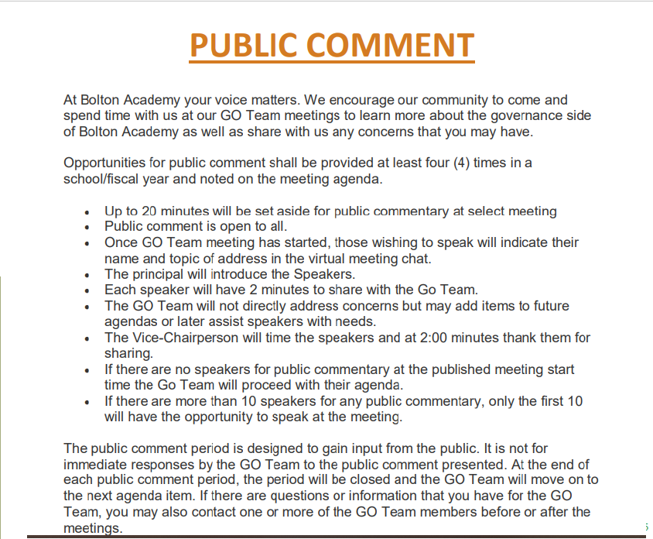

    - The GO Team is not required to schedule Public Comment at every meeting but should be in place for major discussions. Must set a specific time for Public Comment. Must have a clear process for how people sign up to speak.
    - Shavaun Mincey shared Public Comment Protocol on the screen (above). Discussed that we will likely make all GO Team meetings available for Public Comment.
    - Shavaun Mincey shared that historically we have not had contributions during the public comment period, likely due to other opportunities for families to be in touch with feedback and questions.
    - Approval of Public Comment: Motion to adopt made by: Michael Armstrong; Seconded by: Nikki Knox
Members Approving: Shavaun Mincey, Joanna Caceres-Aponte, Meredith Castelan, Celine Browne-Roberts, Avina Gupta
Members Opposing: None
Members Abstaining: None
Motion The motion to approve the Public Comment Protocol passes

  - Set GO Team Meeting Calendar
    - GO Teams are required to have a minimum of 6 business meetings, with at least 4 allowing for Public Comment
    - We selected all meeting dates for 2024-2025
    - Next meeting will be Wednesday, September 18, 2024 at 6:30pm.

 | Date | Time | Virtual or Hybrid | Time for Public Comment? (Yes/No)
1 | September 18 | 6:30pm | Virtual | Yes
2 | October 9 | 6:30pm | Virtual | Yes
3 | December 11 | 6:30pm | Virtual | Yes
4 | January 29 | 6:30pm | Virtual | Yes
5 | March 12 | 6:30pm | Virtual | Yes
6 | April 23 | 6:30pm | Virtual | Yes
7
8

    - Approval of GO Team meeting calendar: Motion to adopt made by: Nikki Knox; Seconded by: Avina Gupta
Members Approving: Shavaun Mincey, Joanna Caceres-Aponte, Meredith Castelan, Michael Armstrong, Celine Browne-Roberts
Members Opposing: None
Members Abstaining: None
Motion The motion to approve the GO Team meeting calendar passes

  - Review, Confirm/Update, and Adopt GO Team Meeting Norms
    - Shavaun Mincey shared GO Team Meeting Norms on the screen. Motion was made to approve norms as displayed on the screen.
    - Approval of GO Team Meeting Norms: Motion made by: Nikki Knox; Seconded by: Celine Browne-Roberts
Members Approving: Shavaun Mincey, Joanna Caceres-Aponte, Meredith Castelan, Michael Armstrong, Avina Gupta
Members Opposing: None
Members Abstaining: None
Motion The motion to approve the GO Team meeting norms passes

- Discussion Items: no discussion items

- Information Items: Principal’s Update
    - Shavaun Mincey shared details about Bolton Academy’s leveling and FY25 budget adjustment. She explained that leveling is the process the district uses to adjust school budget allocations to match student enrollment.
    - The 15-day count enrollment is higher than projected; therefore, Bolton Academy’s budget adjustment is $311,488.
    - As a result of the budget adjustment, Shavaun Mincey shared a summary of changes:
      - Hire a bookkeeper to take on accounting responsibilities
      - Hire an additional part-time support staff focused on math support for grades 2, 3, and 4.
      - Hire an hourly paraprofessional to support the K-5 autism unit.
      - Cover expenses for math and reading assessment subscriptions.
      - Cover expenses to rekey the building and service radios.
      - Purchase teacher supplies.
      - Cover expenses for IB dues.
      - Cover expenses for bus transportation for field trips.

  - Information Items: Resulting discussion after Principal’s Update
    - When asked about volume discounts, Shavaun Mincey explained that school size would not necessarily impact the ability to leverage discounts. The school depends on SOFI to support programs, including teacher appreciation.
    - Shavaun Mincey shared that when setting the 2024-2025 budget, a line item was overlooked which affected the reserve. This error will be addressed during the upcoming budgeting cycle.
    - When asked about applying for grants, Shavaun Mincey shared that the school has not been able to secure substantial grants in the recent past. This is due to our data not being low enough to qualify for grants. Open to creative ideas that would help explore this further. It was shared in the meeting chat that this is a potential resource for grant opportunities: https://gcn.org/

- Announcements
  - New APS superintendent, Dr. Bryan Johnson
    - Dr. Johnson has published a 100-day plan http://www.atlantapublicschools.us/100dayplan
    - Dr. Johnson will be conducting a stakeholder’s survey and community events over the next few months.
    - North Atlanta cluster listening session is scheduled for Thursday, November 7 at 6pm at North Atlanta High School – attendance is encouraged.
  - GO Team member training and orientation
    - All members must complete training for our GO Team to remain in compliance.
    - Contact office if there are any questions or issues accessing training in Elis.

- Adjournment
Motion made by: Avina Gupta Seconded by: Celine Browne-Roberts
Members Approving: Shavaun Mincey, Joanna Caceres-Aponte, Meredith Castelan, Nikki Knox, Michael Armstrong
Members Opposing: None
Members Abstaining: None
Motion The motion to adjourn GO Team meeting passes
ADJOURNED AT 7:21pm
-----------------------------------------------------------------------------------------------------------------------------
Minutes Taken By: Meredith Castelan
Position: Secretary
Date Approved: [Insert Date When Approved]

